Computer Organisation and Architecture Lab

Group number: 65

Members: Pranav Mehrotra ( 20CS10085)

Saransh Sharma (20CS30065)

Q1) RCA using Verilog

1. Half Adder

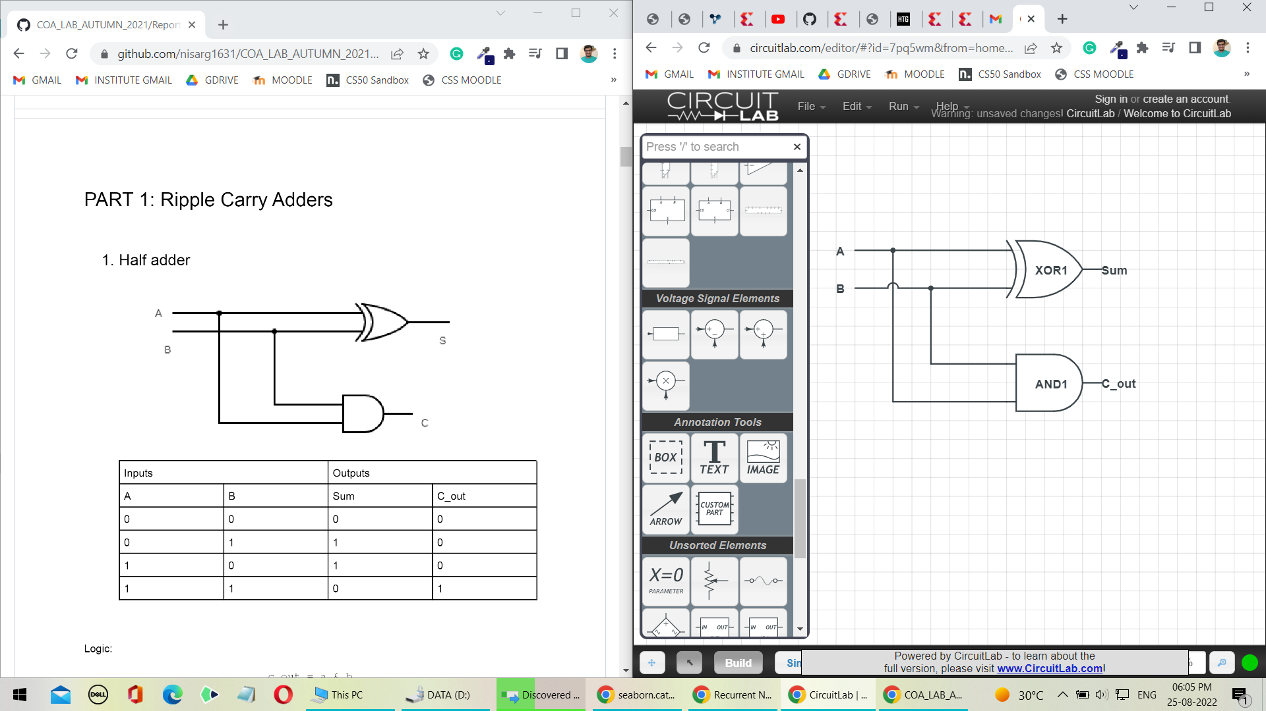

c

s

a

b

|  |  |  |  |
| --- | --- | --- | --- |
| Truth Table of a Half Adder | | | |
| Input | | Output | |
| A | b | s (Sum) | c (carry) |
| 0 | 0 | 0 | 0 |
| 0 | 1 | 1 | 0 |
| 1 | 0 | 1 | 0 |
| 1 | 1 | 0 | 1 |

1. Full Adder

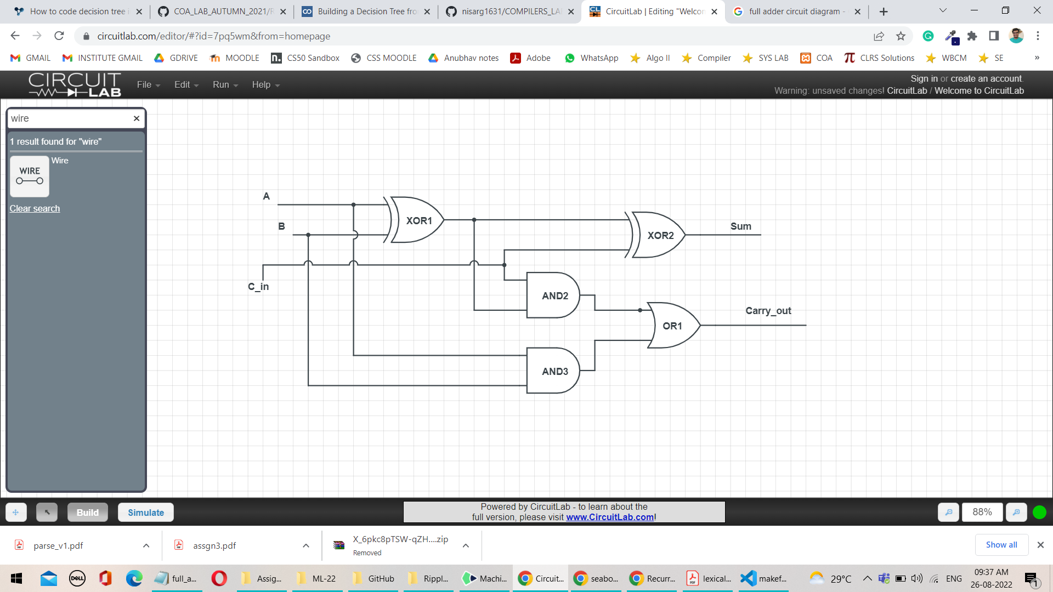

|  |  |  |  |  |
| --- | --- | --- | --- | --- |
| Truth Table of a Full Adder | | | | |
| Input | | | Output | |
| A | B | C_in | Sum | Carry_out |
| 0 | 0 | 0 | 0 | 0 |
| 0 | 0 | 1 | 1 | 0 |
| 0 | 1 | 0 | 1 | 0 |
| 0 | 1 | 1 | 0 | 1 |
| 1 | 0 | 0 | 1 | 0 |
| 1 | 0 | 1 | 0 | 1 |
| 1 | 1 | 0 | 0 | 1 |
| 1 | 1 | 1 | 1 | 1 |

1. 8 – Bit Ripple Carry Adder

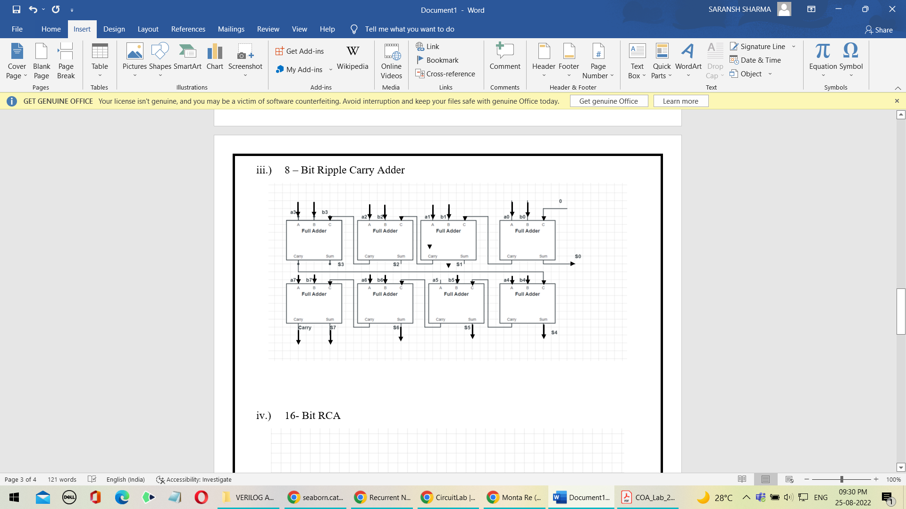

1. 16- Bit RCA

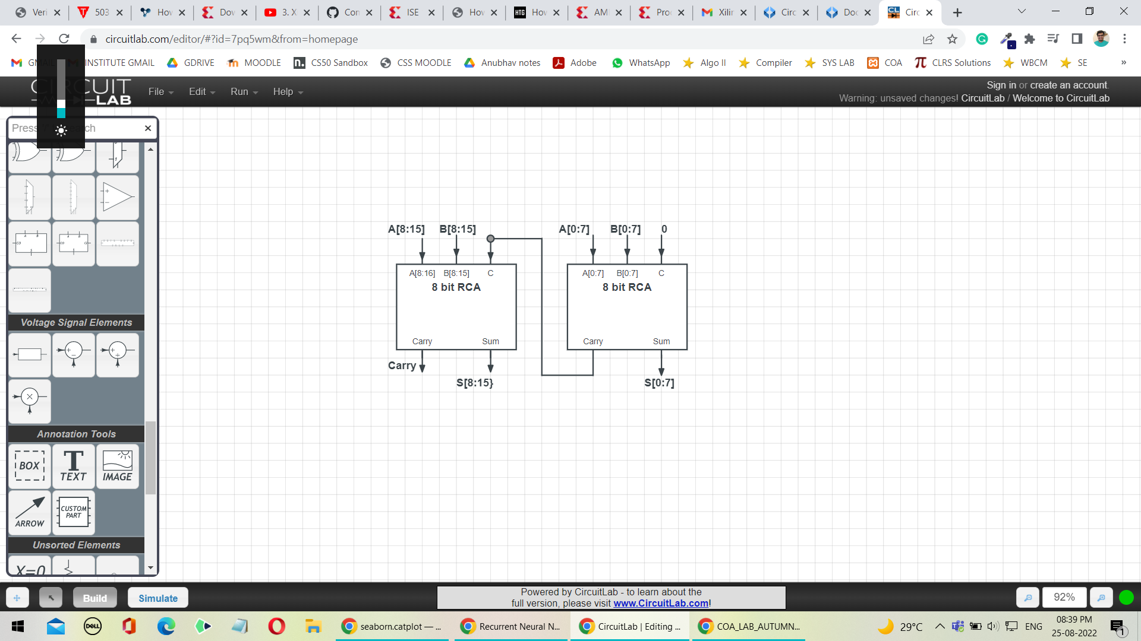

1. 32-Bit RCA

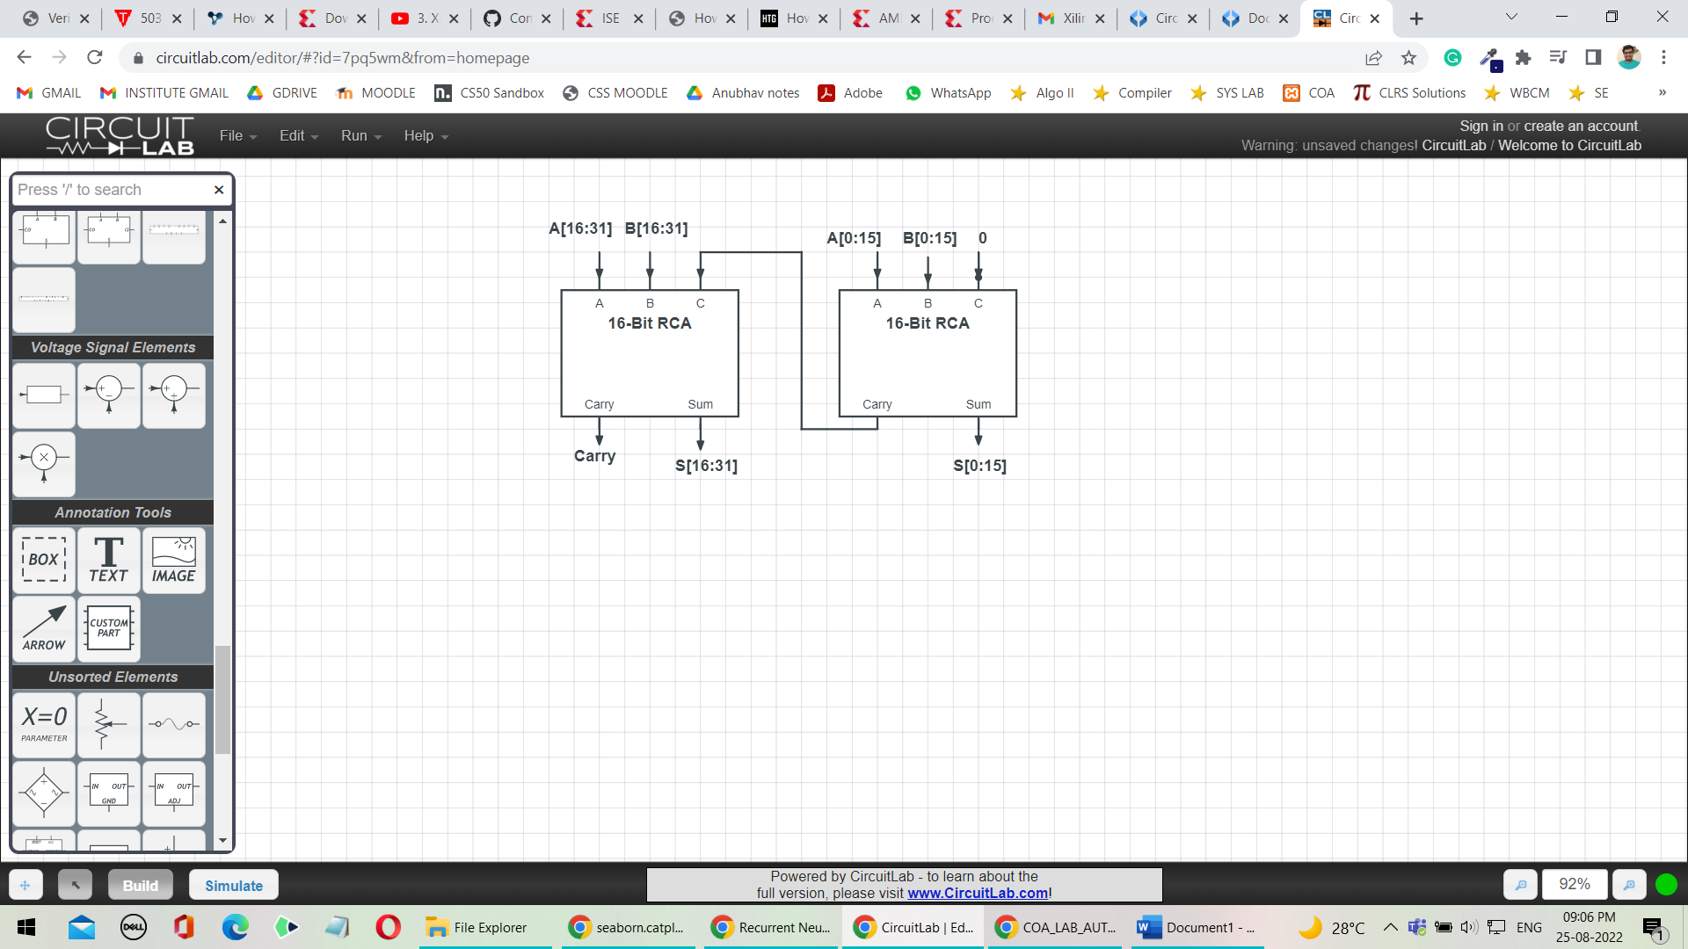

1. 64- Bit RCA

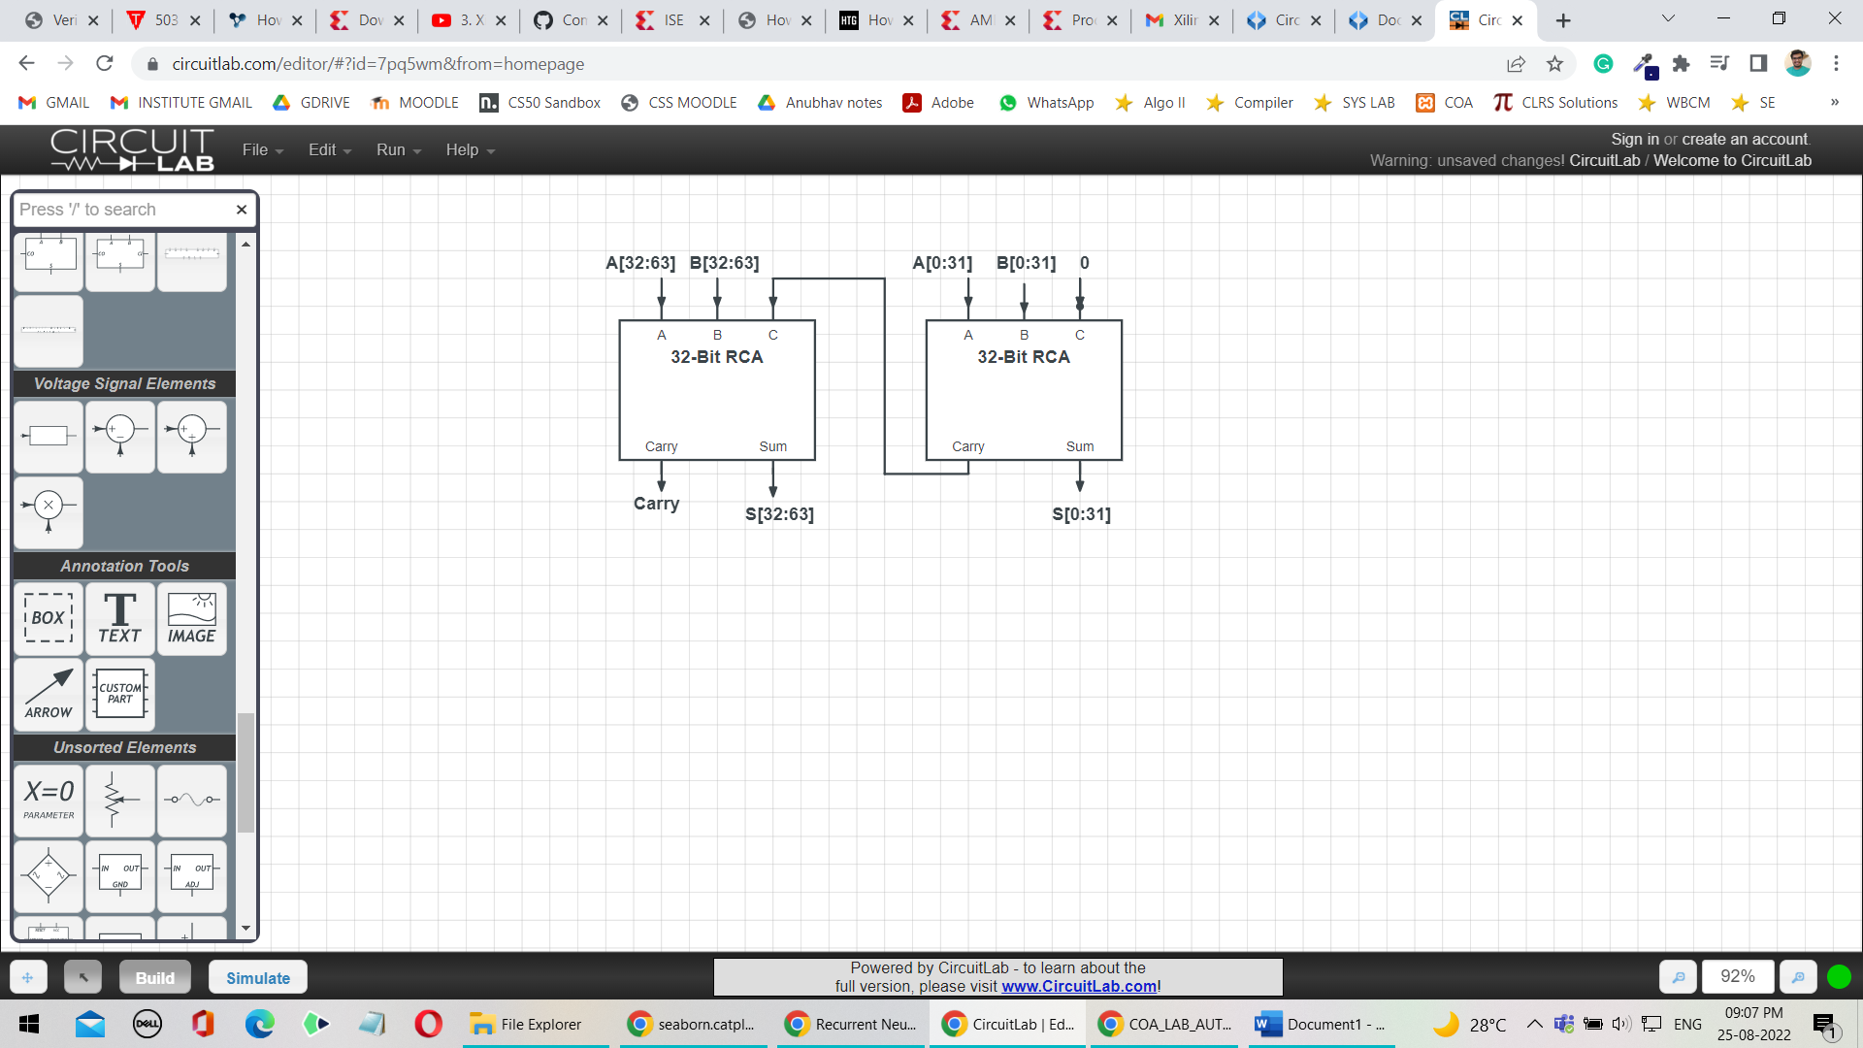

Question: How can you use the above circuit, to compute the difference between two n-bit numbers?

Answer: Ripple Carry adder with input a and b and initial carry bit c0 actually computes the binary sum of a and b, also adding c0 to the LSB of the sum. Thus, c­0 is set to 0 so that RCA adds a and b bitwise and output the result.

For finding difference between two number a and b i.e., a-b we will convert the subtraction problem into addition problem:

i.e., a – b = a + (-b) where (-b) is the 2’s complement of b.

we know that 2’s complement of any number can be calculated by computing 1’s complement of that number and then adding 1 to the LSB of the 1’s complement. That is, (-b) = (~b) + 1 where (~b) is the 1’s complement of b

let a = 100 (4) and b = 010 (2) and n=3

therefore, a – b = 100 – 010

-b = 101 (= ~b) + 1 = 110

a – b = 100 + (110) = 010 (carry_out = 1)

To calculate 1’s complement of a number, we simply have to flip all the bits of that number. That is, we pass every bit of b to a NOT gate to flip the bits of the b. Therefore, whenever we need to calculate difference between a and b i.e., a-b we would first calculate 1’s compliment of b by taking NOT of every bit of b with 1. Since we also need to add 1 to the 1’s complement calculated, we would pass this 1 as c0 to the RCA. Therefore, upon passing a, (~b) and 1 as input to RCA, the n-bit RCA can calculate the difference between a and b.

Synthesis Report

|  |  |  |  |  |
| --- | --- | --- | --- | --- |
| Circuit | Delay (in ns) | Logic Levels | Number of Slice LUTs | Number of bonded IOBs |
| Half Adder | 1.066 | 3 | 2 | 4 |
| Full Adder | 1.246 | 3 | 2 | 5 |
| 8-Bit RCA | 3.471 | 6 | 12 | 26 |
| 16-Bit RCA | 6.167 | 10 | 24 | 50 |
| 32-Bit RCA | 11.559 | 18 | 48 | 98 |
| 64- Bit RCA | 22.343 | 34 | 96 | 194 |

Part-2 Carry Look- Ahead Adders

1. 4- Bit Carry Look-Ahead Adder

The prominent difference between a 4-Bit RCA and a 4- Bit CLA is that a CLA calculates all carries simultaneously instead of waiting for the carry from the previous block to be passed to the current block, thereby, reducing the delay in calculation of sum. Ci that is carry when ith bit of inputs is added can be represented in the form of C0 (initial carry bit).

The logic for CLA for 2 4-Bit input X and Y is shown as:

G[i] = X[i] & Y[i]

P[i] = X[i] **⊕** Y[i]

Where Gi denotes whether X[i] and Y[i] upon addition generate a carry on their own and Pi denotes whether the carry from previous block will be propagated forward or not.

Let C0 be the initial input carry bit.

Sum[i] = P[i] **⊕** C[i]

C[i+1] = G[i] + P[i]C[i]

(Notation: A & B 🡺 AB and A or B 🡺 A + B)

Upon further expanding

C[1] = G[0] + P[0]C[0]  
  
C[2] = G[1] + P[1]G[0] + P[1]P[0]C[0]  
  
C[3] = G[2] + P[2]G[1] + P[2]P[1]G[0] + P[2]P[1]P[0]C[0]  
  
C[4] = G[3] + P[3]G[2] + P[3]P[2]G[1] + P[3]P[2]P[1]G[0] + P[3]P[2]P[1]P[0]C[0]

That is all C[1], C[2], C[3], C[4] can now be represented in terms of C[0].

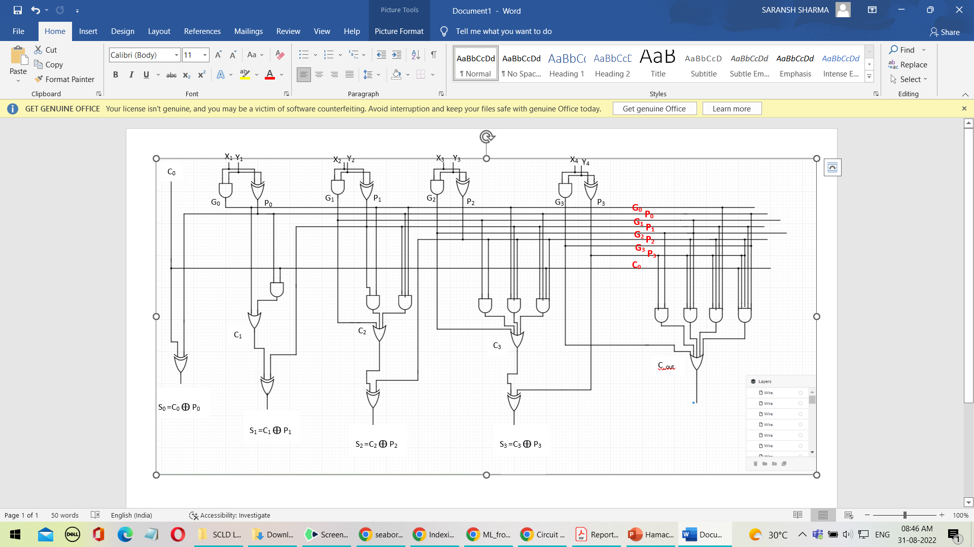

1. 4-Bit Carry Look Ahead Adder (augmented)

The previous circuit will be modified so that the block outputs propagate P and generate G instead of carry-out. This P and G will help us in constructing 16-Bit and higher order CLA using 4-Bit CLA.

The expressions of C[i] and Sum[i] remains the same, i.e.,

Sum[i] = P[i] **⊕** C[i]

C[i+1] = G[i] + P[i]C[i]

P = P[3]P[2]P[1]P[0]

G = G[3] + P[3]G[2] + P[3]P[2]G[1] + P[3]P[2]P[1]G[0] + P[3]P[2]P[1]P[0]C[0]

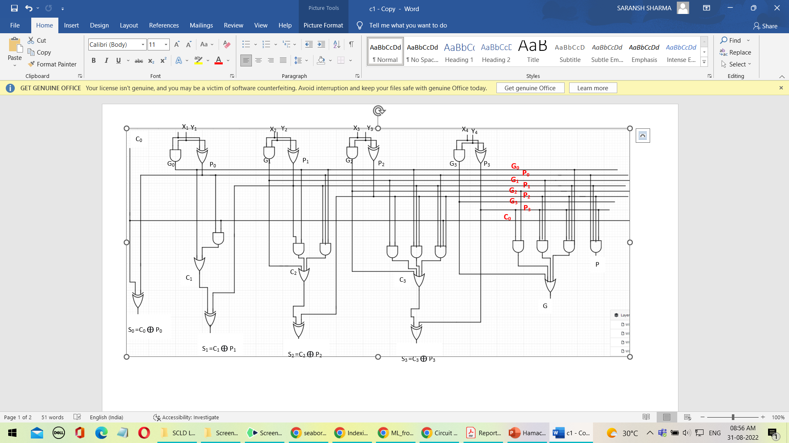

1. 16-Bit Carry Look-Ahead Adder

16-Bit CLA can be constructed by connecting 4 4-Bit CLA and rippling the carry of one block to the next block. C[3], C[2] and C[1] are the internal carries of the circuit.

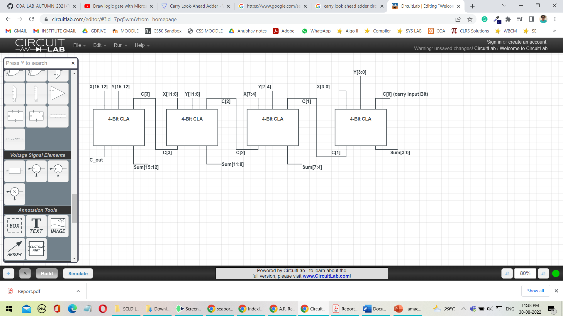

1. 16- Bit Carry Look- Ahead Adder (Look- Ahead Carry Unit)

The previous circuit has to wait for carry from previous block to do further calculations. We can reduce this delay by using an additional look-ahead unit along with 4 CLA’s which can calculate carries using propagate and generate of the 4 CLA’s. let P[0],P[1],P[2],P[3] be the propagates of the 4 blocks of CLA and G[0],G[1],G[2],G[3] be the generates of the 4 blocks of CLA. Using this 16-Bit CLA, delay is further reduced and this circuit can be then used for constructing higher order CLA’s.

Equations involved:

C0 is the input carry

Sum[i] = P[i] **⊕** C[i]

C[i+1] = G[i] + P[i]C[i]

C[1] = G[0] + P[0]C[0]  
  
C[2] = G[1] + P[1]G[0] + P[1]P[0]C[0]  
  
C[3] = G[2] + P[2]G[1] + P[2]P[1]G[0] + P[2]P[1]P[0]C[0]  
  
C[4] = G[3] + P[3]G[2] + P[3]P[2]G[1] + P[3]P[2]P[1]G[0] + P[3]P[2]P[1]P[0]C[0]

Also propagate and generate of this circuit would be:

P = P[3]P[2]P[1]P[0]

G = G[3] + P[3]G[2] + P[3]P[2]G[1] + P[3]P[2]P[1]G[0] + P[3]P[2]P[1]P[0]C[0]

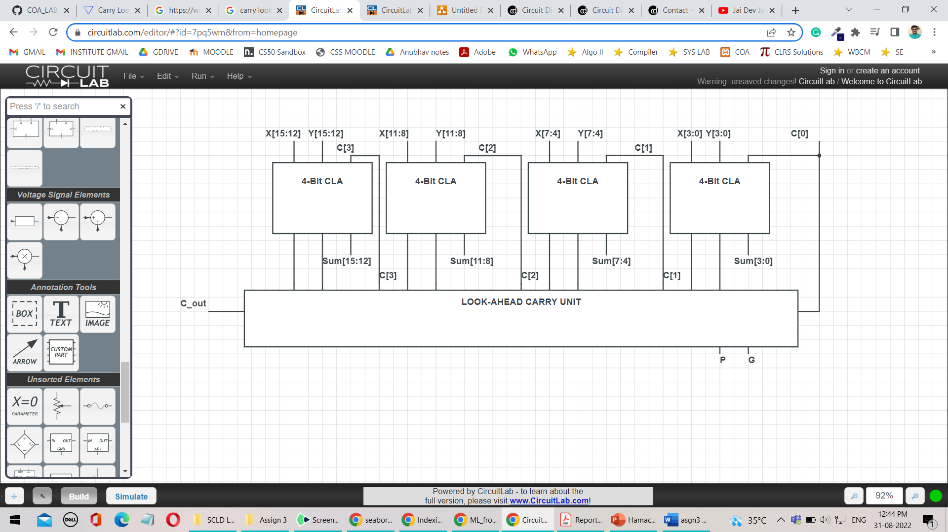

Synthesis Report

|  |  |  |  |  |  |  |
| --- | --- | --- | --- | --- | --- | --- |
| Component | Logic Delay | Route Delay | Total Delay (in ns) | Number of Slice LUTs | Logic Levels | Number of bonded IOBs |
| 4-Bit RCA | 0.497 | 2.697 | 3.194 | 8 | 10 | 14 |
| 4-Bit CLA | 0.249 | 1.874 | 2.123 | 6 | 4 | 14 |
| 4-Bit CLA (augmented) | 0.249 | 2.114 | 2.363 | 9 | 4 | 15 |
| Look Ahead Carry Unit | 0.373 | 2.623 | 2.996 | 7 | 5 | 15 |
| 16-Bit RCA | 0.993 | 5.174 | 6.167 | 24 | 10 | 50 |
| 16-Bit CLA  (with LCU) | 0.745 | 4.563 | 5.30 | 43 | 11 | 52 |
| 16-Bit CLA  (Ripple) | 0.993 | 5.174 | 6.167 | 24 | 14 | 50 |